NAME: Tarun Kumar LSK
REG NO:192225078
COURSE NAME: CLOUD COMPUTING AND BIG DATA ANALYTICS
COURSE CODE: CSA1504
ASSIGNMENT: CONCEPT MAPS -CO1

CONCEPT MAP 1: CLOUD COMPUTING FUNDAMENTALS

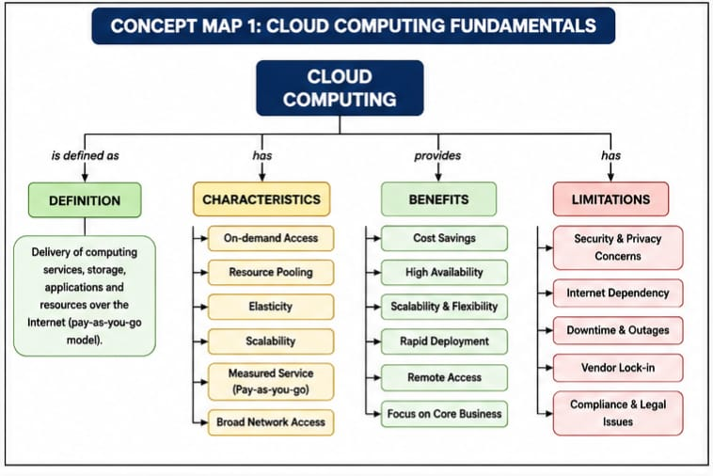

CONCEPT MAP 2: EVOLUTION OF CLOUD COMPUTING
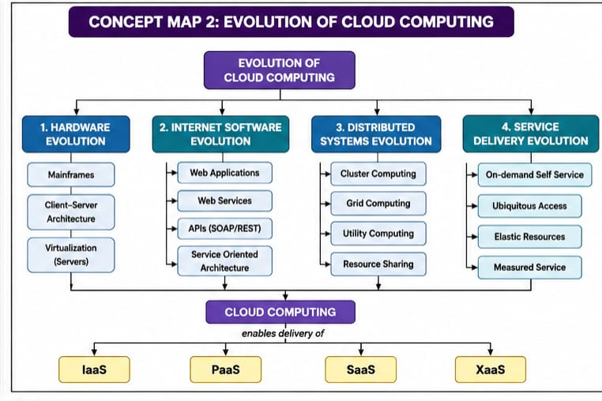
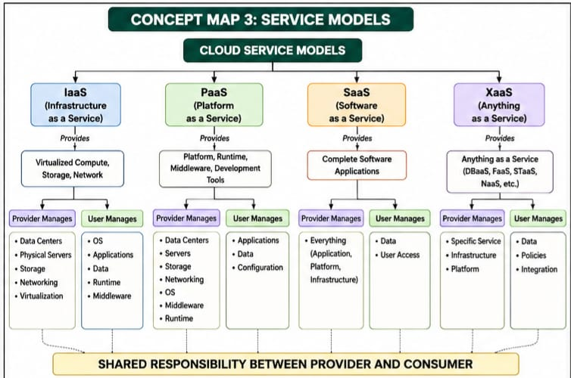
CONCEPT MAP 3: SERVICE MODELS

CONCEPT MAP 4: VIRTUALIZATION AND WEB SERVICES AS ENABLERS OF CLOUD

